Sciences Po April 2015
Centre d'Études Européennes



EUROPOLIX
----------
TECHNICAL MANUAL



Romain LALANDE
romain.lalande@gmail.com
Table of Contents
What is Europolix? 4
Overview of the website 5
Welcome page 5
Login page 5
Administration page 6
Import page 6
Act ids validation page 8
Ministers' attendance validation page 9
Act data validation page 11
Database management page 12
Export page 13
History page 14
Fields to retrieve 15
Database 16
Naming conventions 16
Import tables or tables used for the web application 17
Tables containing act data and used for the statistical analysis 19
Tools used 21
Django files 22
How is organized the website 22
The applications 22
europolix 22
login 23
import_app 23
act_ids 24
attendance 25
act 25
db_mgmt 29
export 29
history 29
Other folders 30
Common module 30
Templatetags 31
Commands 32
Explanation 32
import_app 33
export 33
Statistics module 35
Types of analyses 35
Structure of the module 35
queries.py 35
init.py 36
get.py 37
write.py 38
common.py 39
queries.csv 39
check_queries.sql 39
query folder 39
result folder 41
Parameters 41
factor 41
res 41
count 41
total and res_total 41
query 42
Model 42
variable 42
variable_2 42
res_2 42
exclude_values 43
filter_vars_acts 43
filter_vars_acts_ids 43
exclude_vars_acts 43
check_vars_acts 43
check_vars_acts_ids 44
adopt_var 44
periods 44
question 45
percent 45
Examples 45
Nombre d'actes 45
Nombre de mots moyen 48
Pourcentage d'actes avec un vote public 49
Parmi les votes AdoptCSAbs=Y, pourcentage de chaque Etat membre 50
Pourcentage d'actes avec au moins un EM sans statut 'M' (et au moins un 'CS' ou 'CS_PR') 51
Pourcentage d'actes provenant de la Commission et adoptés par procédure écrite 52
Nombre moyen de EPVotesFor1-2 54
Pourcentage d'actes adoptés en 1ère lecture parmi les actes de codécision 57
Durée de la procédure (= Moyenne DureeTotaleDepuisTransCons ET DureeProcedureDepuisTransCons) 58
Call a query 60
Run a statistical analysis 60
Update the eurlex or oeil url 61
Add a new variable 62
Update the model 62
Update the form (optional) 62
Retrieve the variable 62
Update the view 62
Display the proper name 63
Update the export functionality 63
Run the project on a server 1
Install the project 1
Administration access 1
TO DO 2

What is Europolix?
This section explains what is the project and what it is for.

Europolix is a project started by Sciences Po and Centre d'Études Européennes (CEE) in October 2012. Its aim is to build a database gathering European acts from eurlex (council), oeil (parliament) and prelex (commission).
This project can be seen as a mini website where information is automatically retrieved from the websites above and where experts validate it, act after act.
On top of the creation of a common database, a first goal is to cross validate data between the different European institutions and with an expert to highlight errors. In the end, we wish to have a clean database with no error.
A second goal is to do a statistical analysis of the cleaned acts. To this end, the website allows to extract all the acts of the database into a file readable in a spreadsheet tool.

Overview of the website
This section shows how works the website with screenshots, practical and technical information.

Welcome page
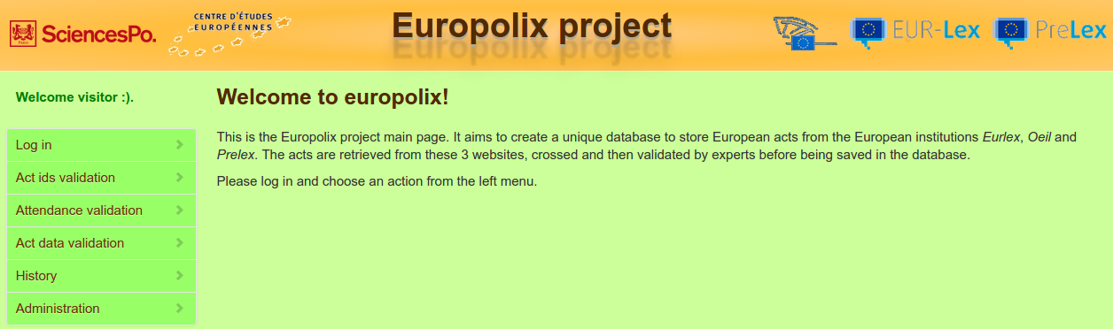
This is the homepage of the website. From the left menu, you can log in and access the administration. You can also import, export and validate acts.

Login page
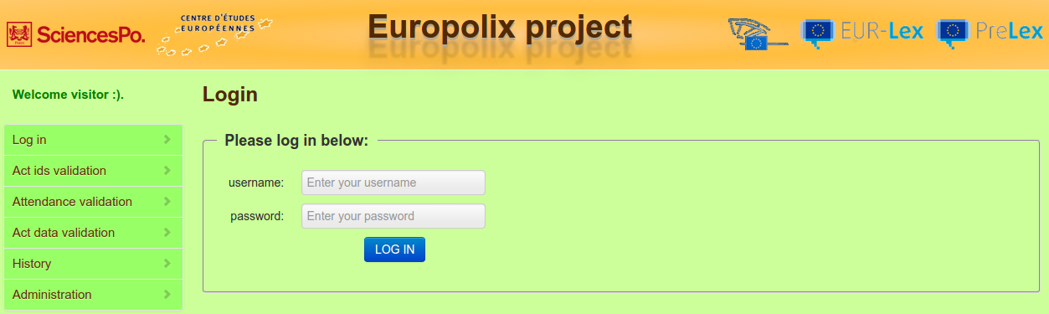
This is the login page (click on “Log in” from the menu). You must log in to get access the other functionalities of the website. If you have no id, you must ask the administrator to use the website.
Enter your username and password. Then click on “Log in”.

Administration page

This is the administration tool (click on “Administration” from the menu). Only an administrator or staff with special privileges can access it.
Fill in your username and password and click on “Log in”.
The Django administration comes with a bunch of functionalities and can be customized. For more information, please have a look at https://docs.Djangoproject.com/en/dev/ref/contrib/admin/.

Import page
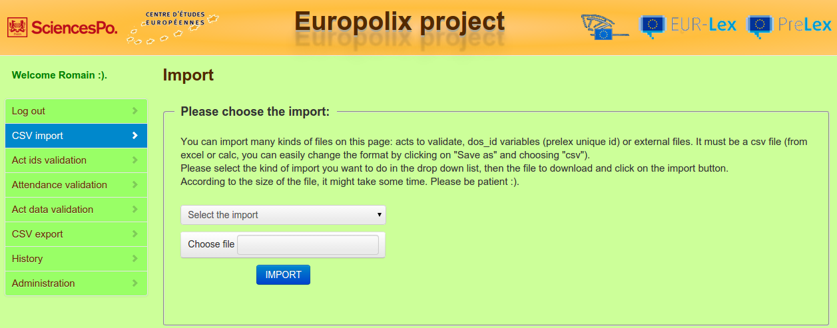
This is the import page. You can import different csv files that are first saved on the server and then processed.
  - Import acts to validate: Import a file containing information on acts (information found in monthly summaries and then gathered in a spreadsheet document). Two steps:
      - 1/ the content of the file is saved under the tables Act (main data of the acts), ActsIds (ids of the acts), adopt_cs_contre (adopt_cs_contre variable) and adopt_cs_abs (adopt_cs_abs variable).
      - for each act newly inserted, we retrieve corresponding data (ids only) from the eurlex or oeil websites. Finally we update the database with this new information. A message is displayed if errors are encountered during the import.
  - Import DosId: Import a file containing prelex unique id (called dos_id) and the no_celex variable to do the mapping (no_celex is contained either in the VAL_CHP_SUP_01 or VAL_CHP_SUP_03 column. The content of the file is saved in the database under a table called ImportDosId.
  - Import CodeAgenda*: This file is used to do the mapping between the code_sect_* variable of the Act model and the code_sect variable of the CodeSect model; it also associates a code_agenda variable (CodeAgenda model) to each code_sect variable (CodeSect model).
  - Import RespPropos* and relative data: This file fills the data about each resp_propos variable (eurlex). Each resp_propos has a name, nationality, national party and party family. Each resp_propos_* variable of the Act model is linked to the Person model (resp_propos for eurlex and rapp for oeil). In the Person model, the country variable is linked to the Country model while the party variable is linked to the Party model. The party_family variable is present in the party_family association that links one country to one party.
  - Import DGProposition* and SiglesDG*: This file associates each dg_* variable of the Act model with a dg name and a sigle (and a dg with a number for old dg names, if any). The DG model does the mapping with the name of the dg, while the DGSigle model associates each dg variable to a sigle. The DGNb model and the dg_nb association are used to do the mapping for dg variables with a number in their name.
  - Import ConfigCons: This file is used to do the mapping between config_cons variables (ConfigCons model) and code_sect variables (CodeSect model).
  - Import AdoptPCAbs and AdoptPCContre: This table links an act (Act model) to its adopt_pc_contre (adopt_pc_contre association) and adopt_pc_abs variables (adopt_pc_abs model)
  - Import NationGvtPoliticalComposition: This file contains 3 columns: a start date, and end date and a “gvt compo” column. It represents the main political parties of each European nation with their respective dates of appearance and disappearance. The “gvt compo” column contains the country and its list of parties and party families for a given period of time (defined by the start_date and end_date variables). These dates variables are stored in the GvtCompo model which is linked to the Party model via an association and to the Country model via another association. It is also linked to the Act model to show the governments in power at the date of adoption of each act.
  - Import opal file (NP variables): This file links an act (Act model) to its np variables (NP model) through its no_celex variable. There is a case_number, an act_type and an act_type variable. Each NP model is linked to a country through the Country model.
  - Import new Attendance of ministers: This file describes the ministers that attended council meetings. For each council meeting, there is the country of each minister, along with their verbatim and status. Each council meeting is linked to the Act model through the act ids (releve ids) and / or no_celex. Each verbatim is stored in the Verbatim model. The min_attend association links an act, a verbatim and a country. status variables link a verbatim and a country through the status association.
  - Import party families of Rapporteurs: link each rapp variable (Act model) with a party_family (party_family association). The file contains matchings between party and party_family variables.
  - Update Attendance of ministers: Same thing than Import new Attendance of ministers but is used to update already existing ministers' attendances (because they contained wrong data when they were saved). In this case, the link with the Act model is made with the no_celex only.

The web form indicates the variables and their order for each file to import. At the end of the import process, a message is displayed if errors were encountered (in case of already existing record, incorrect data, etc.).

First of all, choose the import to perform in the drop down list. Then click on “Choose file” and select the file to import (it must be a csv file). Finally click on “Import” to launch the import. It can take a while...

After the step Import acts to validate, you can validate the ids of the acts you just imported (see below).

Act ids validation page
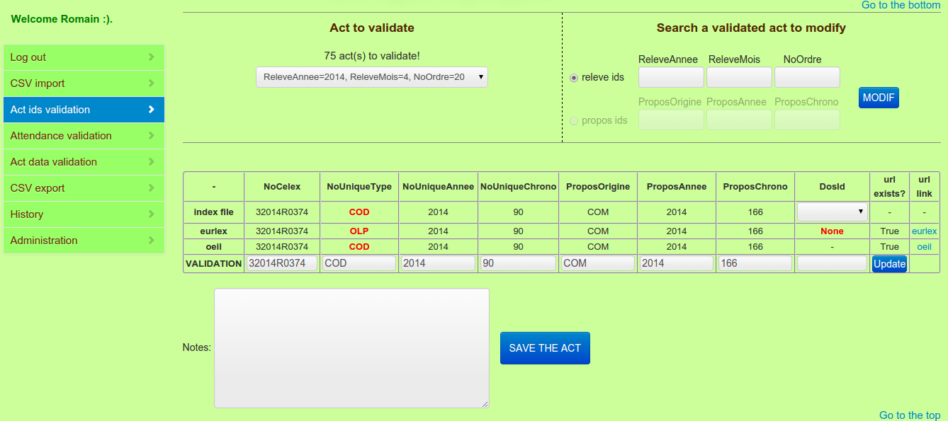
You can perform two actions on this page:
- validate ids of an act that has already been imported (see Import page): select an act in the drop down list to validate it.
- modify ids of an act that has already been validated: select releve ids to find an act with its releve_annee, releve_mois and no_ordre variables or select propos ids to find an act with its propos_origine, propos_annee and propos_chrono variables. Fill the corresponding text boxes and click on the MODIF button to validate the act.

Information related to the selected act is displayed from the database (ActsIds table) to an html table. All the fields are displayed in column regarding its source in row. The first source (row) corresponds to the csv file (which can be imported – see previous paragraph), the second row corresponds to the information retrieved on the eurlex page and the third one on the oeil page. The last raw called “Validation” is used to validate and save the true data of the act. By default, it takes the values of the csv file source.
The dos_id variable does not exist in the csv file. The drop down list in the DosId column displays all the values that match the no_celex of the selected act, from the imported file containing prelex unique ids (see Import page). The dos_id displayed is the one used by default in the validation row.
When information do not match (between sources), data is displayed in red, which means that there is an error and an expert is required to validate the act. If there is an error, the expert can change the value of the field. When everything is checked, the act can be saved (ActsIds table).

You can also update the ids of an act if you think they have been updated on eurlex or oeil or if one of these sources was not available at the import of the act or if you made a mistake when you first validated it. Click on the Update button at the bottom right corner of the table and wait for the update of the ids of the act.

Select the act to validate in the drop down list (or to modify by entering the corresponding releve_ids in the text boxes) and check the corresponding information in the table below. Modify fields if needed in the row “Validation”. You can check or / and add notes regarding the act. Finally, click on “Save” to validate and save the act.

After this step, you can validate the ministers' attendance of any act you have already imported (see below).

Ministers' attendance validation page
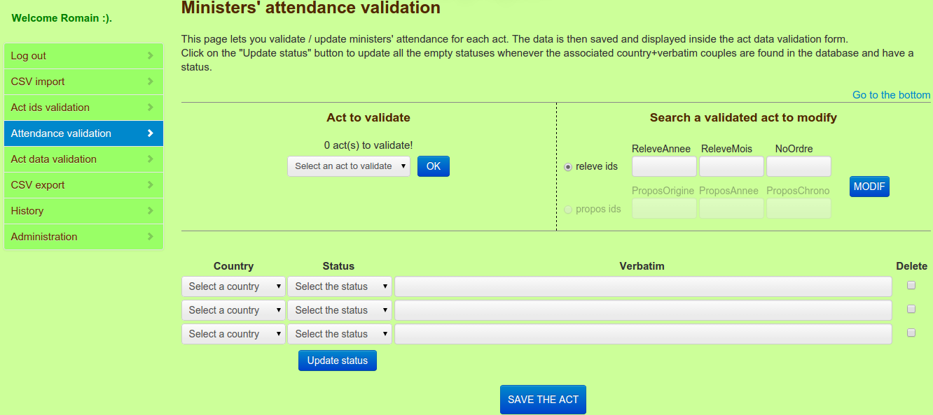
This page displays a list of countries and minister's status and verbatim that attended the council meeting concerning an act to validate. This is possible thanks to the extraction of a pdf whose url is included in csv files that were imported previously (see Error: Reference source not found to learn how to retrieve the data of those pdf files).

You can perform two actions on this page:
- validate the ministers' attendance of an act that has already been imported (see Import page): select an act in the drop down list and click on the OK button to validate it.
- modify the ministers' attendance of an act whose ministers' attendance have already been validated: select releve ids to find an act with its releve_annee, releve_mois and no_ordre variables or select propos ids to find an act with its propos_origine, propos_annee and propos_chrono variables. Fill the corresponding text boxes and click on the MODIF button to validate the act.
modify ids of an act that has already been validated:

Information related to the selected act is displayed in 3 columns: country, status and verbatim. For each minister attending the council meeting, we have retrieved his country, verbatim (position title) and status (code created to facilitate the statistical use of the verbatim – see codebook).

You can also update the status by clicking on the Update status button. This will search matches of couples (verbatim+country) and will try to associate the corresponding status to all the same couples (verbatim+country) with no status.

There is the possibility to delete one row by ticking the checkbox Delete in the last column (and clicking on the SAVE button) and adding extra rows using the 3 blank lines at the bottom.

Select the act to validate in the drop down list (or to modify by entering the corresponding releve ids or propos ids in the textboxes) and check the corresponding information in the table below. Modify fields if needed (choose another country or status in the corresponding drop down lists or change the verbatim). Finally, click on “Save” to validate and save the act.

After this step, you can retrieve information of the acts you just validated for the statistical analysis (see below).

Act data validation page
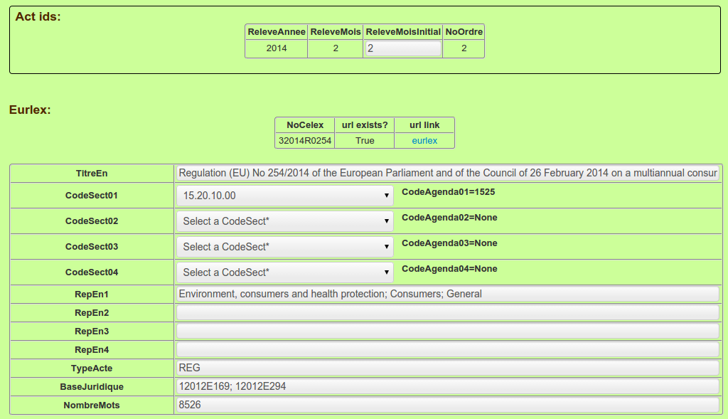
You can perform two actions on this page:
- validate data of an act that has already been imported (see Import page): select an act in the drop down list to validate it.
- modify data of an act that has already been validated: select releve ids to find an act with its releve_annee, releve_mois and no_ordre variables or select propos ids to find an act with its propos_origine, propos_annee and propos_chrono variables. Fill the corresponding text boxes and click on the MODIF button to validate the act.

Acts data can be retrieved and then validated on this page. You can select acts for which ids have been validated only. Data related to one act is displayed from the database (Act table) to html tables. For each source (eurlex and oeil), a first table recalls the ids and the url while a second table displays the corresponding retrieved data. The NationGvtPoliticalComposition variable, at the end of the eurlex table, shows the composition of each national government when the act was adopted. The two other tables show the ministers' attendance data (country and status only) and the opal data with one row per country.
All the retrieved fields are displayed in row. The first column corresponds to labels and the second one corresponds to retrieved data. If there is an error, the expert can change the value of any field. When everything is checked, the act is ready to be saved (Act table).

Select the act to validate in the drop down list (or to modify by entering the corresponding releve ids or propos ids in the textboxes) and check the corresponding information in the tables below. Modify fields if needed in the second column of the eurlex or oeil table. NationGvtPoliticalComposition, ministers' attendance and opal data cannot be modified, but ministers' attendance data can actually be modified in another form (see Ministers' attendance validation page). You can check or / and add notes regarding the act. Finally, click on “Save” to validate and save the act.

In fact there is one more action you can perform on this page...

Database management page
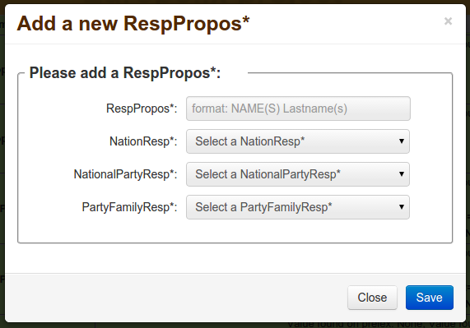

On the Act data validation page, after selecting an act, you can Add a new rapp, dg, or resp variable:
- in front of each rapp variable, you can click on “Add a new Rapporteur*” to add a new rapp variable (name, country and party) .
- in front of each dg variable, you can click on “Add a new DGProposition*” to add a new dg variable (dg and dg_sigle) .
- in front of each resp variable, you can click on “Add a new RespPropos*” to add a new resp variable (name, country, party and party_family) .

The screenshot above can be seen when JavaScript is activated. If JavaScript is not activated, it's a completely new page that you see:
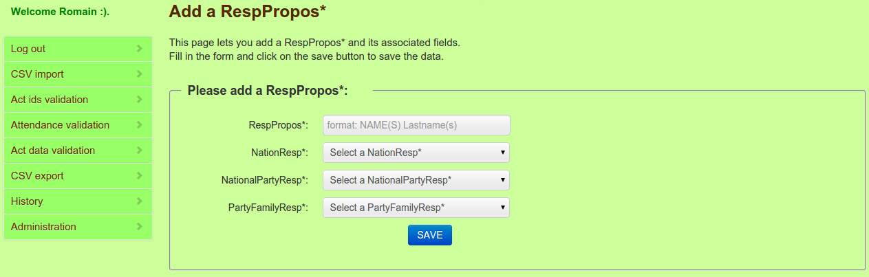
This interface is called database management because a few functionalities could be added if needed, such as the possibility to update or delete an existing record as well as the possibility to manage other models.

After this step, you can export the acts you already imported and validated in a csv file (see below).

Export page
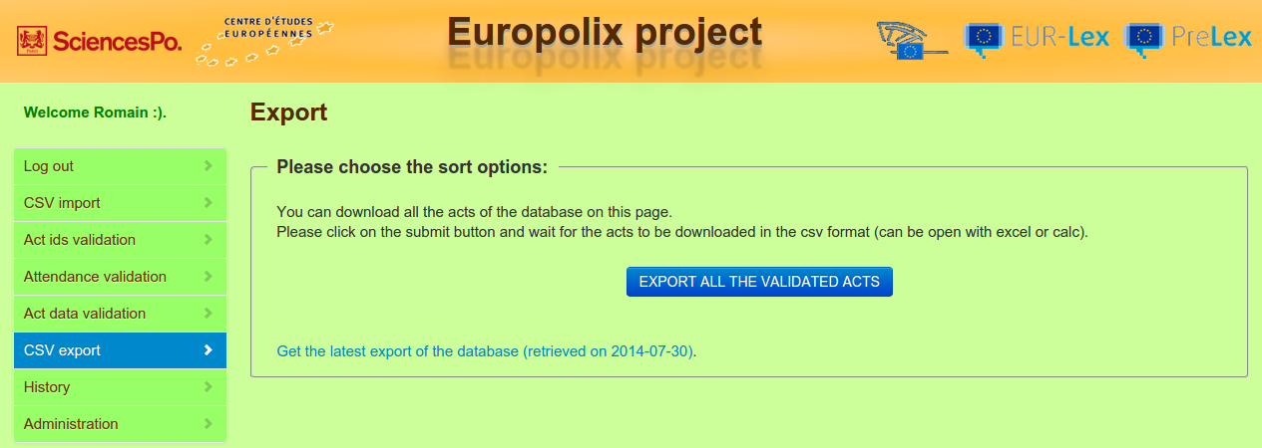
This is the export page. Once acts have been imported, ids validated and data retrieved, you can choose this tool to export them under the csv format.
This action exports acts saved and validated only, from the database, in two steps: a csv file is created on the server and contains the data of the database, then it is sent and downloaded by the web browser.

To download the validated file, click on the Export button to start the download.

You can also get the latest export of the database by clicking on the link at the bottom of the form. This file is exported on the server automatically, every Sunday. Choose this option if you have problems exporting the acts.

After this step, acts are ready for the statistical analysis :).

History page
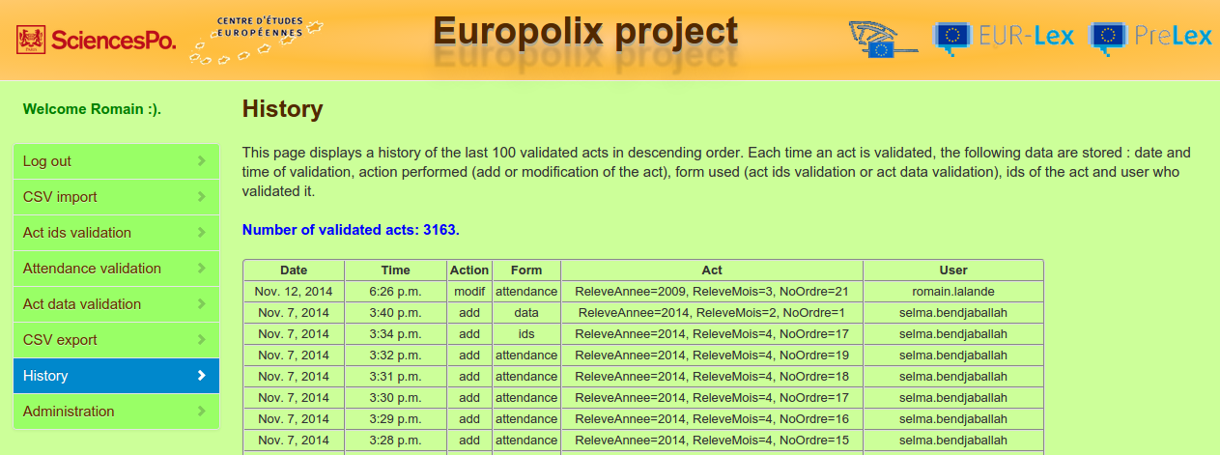
This page shows a history of the last 100 actions performed, useful for validators to help them remember their most recent tasks.
There are 6 columns:
- the date of the performed action
- the time of the performed action
- the action itself: add when an act is added (selection of an act from the drop down list) or modif when an act is modified (after entering its releve ids or propos ids in the textboxes and clicking on the Modif button)
- the form used: ids for the Act ids validation form, data for the Act data validation form and attendance for the Ministers' attendance validation form
- the act column displays the releve ids of the act
- the user column displays the user who has performed the action

Fields to retrieve
This section gives some information about the retrieved fields from the index files, eurlex url, oeil url and the external tables.

These fields can be found in the models.py files of the act_ids, act, attendance and import_app applications. Some technical explanations are given in the source code, but the explanation of each field, in natural language, is given in the codebook.

In the future, fields should be renamed in English. To this end, a file for ids and a file for all the other variables have been created to do the match between variable names used by the program and variable names that are displayed / exported. These files are located at acts_ids/var_name_ids.py for variables concerning ids of the acts and act/var_name_data.py for variables concerning data of the acts. They use dictionaries, with names used by the program as keys and names for the display as values. See the source code for more details. These files should be used each time you want to display or export a variable name.

Let us see now how these fields are stored in the database.

Database
This section describes the database and relations between tables (models in Django vocabulary).

Naming conventions
To create a name for a model, Django concatenates the application name, an underscore “_” and the model name. Everything is lowercased. For example, the DG model of the act application is named act_dg.
For an association that links two tables:
- the association is manually created : the model name follows the convention above. For exemple, the PartyFamily association of the act application is named act_partyfamily.
- The association is created by Django: in such a case, there is a manytomany variable created in one particular model. We then use the name of the model and the name of the variable, joined by an underscore, to generate the name of the association. Let's take the example of the dg_nb variable of the DG model of the act application (used to join the DG and DGNb models). The name of the association is then: act_dg_dg_nb.

Import tables or tables used for the web application
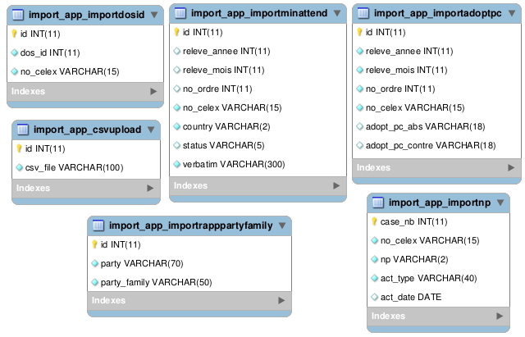

These tables all come from the import_app application. They are only used for the import of external tables (see Import page) and for populating all the tables that will serve the statistical analysis. They are temporary tables and therefore have no physical relation with any other table.

- import_app_importdosid: This model is used to populate the dos_id variable of the ActIds model. The link is made with the no_celex variable.
- import_app_importrapppartyfamily: This is used to populate the party_family variable of the PartyFamily model so as to link every party of rapporteurs (Party model) to a party family.
- import_app_importnp: This model concerns the opal project. The variables are used to populate the variables of the NP model; the link is made with the no_celex variable.
- import_app_importminattend: This model is used to populate the MinAttend, Verbatim and Status tables. The link is made via the no_celex variable.
- import_app_importadoptpc: This model is used to populate the act_act_adopt_pc_abs association (with the adopt_pc_abs variable) and act_act_adopt_pc_contre association (with the adopt_pc_contre variable). The link is made via the no_celex variable.
- import_app_csvupload: This model is used for the web application only. It shows the path of each imported file and facilitates import of files with Django.
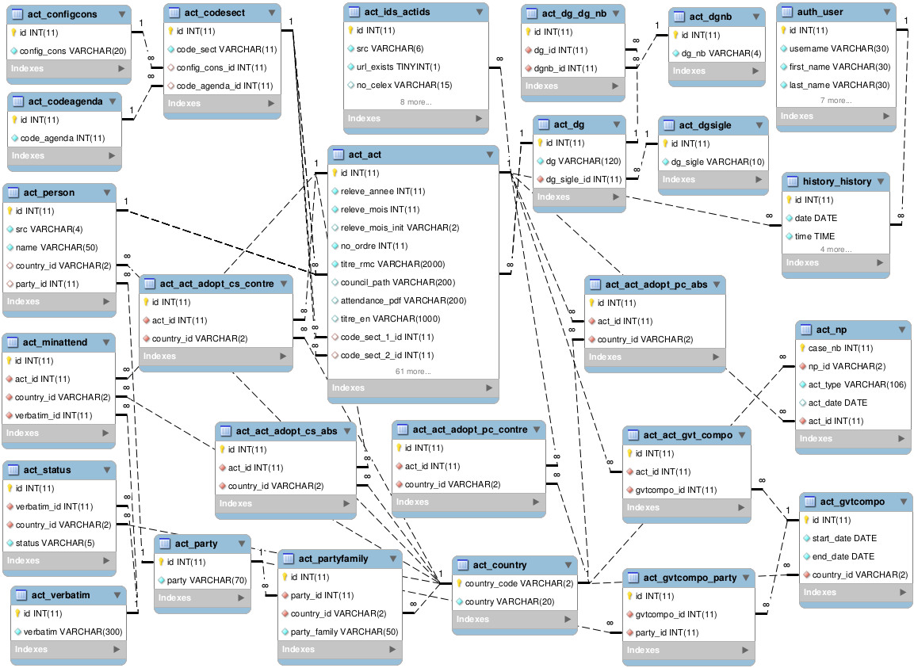

Tables containing act data and used for the statistical analysis

The main table is act_act. All the other tables are directly or indirectly linked to it. It contains data for each act. Each act is identified by its releve ids (releve_annee, releve_mois and no_ordre variables). The table also contains variables taken from the monthly council summary, from the eurlex and oeil and websites and from external tables (see Import page). You can validate / see all the variables of this table in the Act data validation form (see Act data validation page).

The second main table is act_ids_actids. It contains the ids of each act retrieved on every source (identified by the src variable): the ids for eurlex (no_celex) or the ones for oeil (no_unique_type, no_unique_annee, et no_unique_chrono) or the ones for prelex (propos_origine, propos_annee and propos_chrono or dos_id) or the validated ids (true ids), coming from the index files, that were filled or validated in the Act Ids validation form (see Act ids validation page). Each act_act instance has exactly 4 act_ids_actids instances, one for each source. Once the ids of an act are validated, only its ids from the index source are used by the application (true ids).

The act_codesect, act_configcons and act_codeagenda models are used to populate the code_sect_1_id, code_sect_2_id, code_sect_3_id and code_sect_4_id variables of the act_act model. They are also used to display the 4 different code_sect with their associated code_agenda variables as well as the config_cons variable, for a given act, in the Act data validation form (see Act data validation page). Each code_sect_*_id of the act_act model has one act_codesect instance and each act_codesect instance has one act_configcons and one act_codeagenda instance.

The act_dg, act_dgsigle, act_dgnb and act_dg_dg_nb models are used to populate the dg_1_id, dg_2_id and dg_3_id variables of the act_act model. They are used to display the two dg with their sigle, for a given act, in the Act data validation form (see Act data validation page). Each dg_*_id of the act_act model has one act_dg instance and each act_dg instance has one act_dgsigle instance. Sometimes dg appear with numbers instead of names. They are listed in the table act_dgnb. To get their real names, there is an association act_dg_dg_nb that maps dg with names (act_dg) and dg with numbers (act_dgnb). One act_dg instance can have many act_dg_dg_nb instances and one act_dg_dg_nb instance can have many act_dg instances.

The act_country model gives a list of country codes and countries of the European Union and is linked to many models.
The act_party model gives a list of political parties of the European Union and is linked to many models.

The act_partyfamily model gives a list of political party families of the European Union and links a party to a country. One party and one country identify a unique party family.

The act_person model is used to populate the rapp_1_id, rapp_2_id, rapp_3_id, rapp_4_id, rapp_5_id, resp_1_id, resp_2_id and resp_3_id variables of the act_act model. A person is either a rapporteur (oeil) or a responsible (eurlex), which is identified by the src variable. The model aims to display the 5 different rapporteurs / 3 different responsibles along with their country, party and party family, for a given act, in the Act data validation form (see Act data validation page). Each person has a name, a country, a party and a party family.

The act_np model is used to display the opal variables of an act (act_act model) in the Act data validation form (see Act data validation page). Each act can be associated to many act_np instances and each act_np object is associated to one act and one country.

The act_act_adopt_pc_abs, act_act_adopt_pc_contre, act_act_adopt_cs_abs and act_act_adopt_cs_contre models are used to populate the adopt_pc_abs, adopt_pc_contre, adopt_cs_abs and adopt_cs_contre variables of the act_act model. They are displayed in the Act data validation form (see Act data validation page). Each of these variables links an act with a country. One act and one country can have many adopt_pc_abs, adopt_pc_contre, adopt_cs_abs or adopt_cs_contre variables.

The act_gvtcompo model indicates the composition of the European governments for a given period defined by a start date and an end date. Each period is associated to a country and a list of parties and party families. One period is associated to one or many acts (act_act model) and one act is associated to one or many periods. Those variables are displayed in the Act data validation form (see Act data validation page).

The act_minattend model indicates the attendance of ministers for every European council. Each minister who attends a council has a country, a position identified by a verbatim (act_verbatim model) and a status (act_status model), that is, a code for the verbatim. Every act (act_act model) has many ministers' attendances and so many associated verbatims, status and countries. A country and a verbatim identify a unique status. For a given act, minister's attendances can be checked and validated, in the Attendance validation form (see Ministers' attendance validation page); the same data are also displayed in the Act data validation form (see Act data validation page).

The history_history model shows, for each validated form, the user who validated it (auth_user model), the date and time of validation, the action performed (add or modification) and the form used (act data, act ids or ministers' attendance). Each act and each user can be seen in many history_history instances but each history_history instance is associated to one act and one user only. A history of the last 100 actions performed can be seen in the History page.

So far we have seen what has been created for the project. Let us now see which tools were used.

Tools used
This section describes the tools used for this project.

- operating system: linux (lubuntu 14.04)

- programming language: python (version 2.7.6). This is the language used for the project. Easy to learn, short to write (many built-in functions) and quite fast.

- framework: Django (version 1.4.2) [English documentation: https://docs.Djangoproject.com/en/1.4/ - French documentation: http://openclassrooms.com/courses/developpez-votre-site-web-avec-le-framework-Django]. This python framework is used to quickly develop applications on the Internet. It tends to differentiate design and content. Its goal is to facilitate a developer's life and maintenance. Each Django application is composed of 4 layers:
    - Model: it is the database layer. It creates a connection with the database. No need to write sql queries, Django takes care of that! In a model, precise the tables and fields you want to use (for a select, insert, update or delete operation).
    - Form: it is the web form layer. Declare the fields to appear in your web form and describe a custom validation if needed.
    - View: it is the content layer. You describe / create what you want to display and use the model and form previously created.
    - Template: it is the display layer. A template is mainly html code with Django variables and expresses how the html page is rendered.
    - An other kind of file is essential for Django applications: the url file. It tells Django what view and parameters need to be called for a given url.

- back-end database: mysql

- MySQL-python version 1.2.5 is used to connect the python program to a MySQL database, which is crucial to the project as it is using a MySQL backend database.

- html extraction: BeautifulSoup (version 4.3.2) [English documentation: http://www.crummy.com/software/BeautifulSoup/bs4/doc/], regex and python string manipulation tools. These tools are used to extract information on acts from the eurlex and oeil websites.

- pdfminer, version 2011-05-15, used to extract some pdfs for the ministers' attendance

- dbms: mysql Workbench (version 5.2) [optional]

Django files
This section gives a general explanation and purpose of all the important folders / files of the project. For more details, please consult the files directly: they are all commented.

How is organized the website
Django is organized in applications, each of them containing a specific functionality of the website.
At the root of the server, act, act_ids, attendance, db_mgmt, europolix, history, export, import_app and login applications can be found. They are described in the next section.

At the root of the server, you can also find other folders:
- common: common files used by several applications (see Common module).
- media: contains csv files either imported (import subfolder) or exported (export subfolder).
- static: contains static files such as css and js files:
  - admin: css, js and images files for the administration tool.
  - bootstrap: bootstrap files used by the css and js files of the project.
  - europolix: css, js and images files of the project.
  - jquery_gentleSelect: jquery plugin used to display the adopt_cs and adpot_pc dropdown lists (Act data validation form).
  - jquery.min.js: jQuery file, used by js files of the project.
  - jQueryRotate.min.js: jQuery file to rotate images, used on the image in front of the adopt_conseil variable (Act data validation form).
- templates: this folder contains the html rendering of each page. At the root, index.html is the template of the homepage while base.html contains common elements to each page and menu.html contains the left menu. For details about application pages, see next section.

The root of the server also contains files:
- europolix.log[.*]: log files of the applications, used to debug the application on the remote server.
- manage.py: this very important file in any Django application allows to run commands, to start the local server, to synchronize the database, to run some tests, etc.
- README.md: this file explains how to deploy and run the application on a server.
- requirements.txt: this file contains a list of packages to install to have this project working.

The applications
Let us see now each application in details. They are physically organized as folders located at the server root.

europolix
europolix is the first and main folder. It essentially contains the homepage and allows to activate the administration part. Here is a short explanation of each important file of the folder:
- settings.py: this file is very important since it contains all the specificities of your project. It contains the database access (including the password), the applications to load, path for media and static files, path for templates and more...
- urls.py: contains the url to each application of the website. It also activates the Django administration tool (automatically created by Django!).
- views.py: contains the reload_menu view called to reload the left menu when a user logs in or logs out.
- the file index.html within the templates folder is used to render the homepage and is called from the urls.py file.

login
This is the login folder, linked to the Login page. It allows the user to authenticate and access all the functionalities of the website. Here is a short explanation of each important file of the folder:
- views.py: contains the login_view view called to render the connection page. Allows the user to enter his ids and checks them.
- The index.html file within the folder templates/login is used to render the login page and is called by the login_view view.

import_app
This is the import_app folder, linked to the Import page. It allows the user to import various csv files containing acts to validate and external tables linked to these acts. Here is a short explanation of each important file of the folder:
- urls.py: contains all the possible urls of the application.
- models.py: this file contains the database model of the application. It contains the ImportDosId model (imported dos_id), ImportNP (imported opal variables), ImportAdoptPC (imported adopt_pc_contre and adopt_pc_abs variables), ImportMinAttend (imported ministers' attendance variables: verbatim, country, status), ImportRappPartyFamily (makes the correspondance between party and party_family variables for a rapporteur) and the CSVUpload model which contains the name of the imported files. This last model is not really useful but is the easiest way to import files with Django.
- forms.py: contains the CSVUploadForm form which uses the CSVUpload model. It defines the form used by the view and displayed by the template.
- get_ids_eurlex.py and get_ids_oeil.py are used to retrieve ids from eurlex and oeil respectively. Collected information is stored in a dictionary.
- get_ids.py is the main file called by the view. It builds the urls, checks their availability and call the files above to retrieve ids from the eurlex and oeil websites.
- views.py: contains the import_view view called to render the import page and calls the following functions:
  - get_data_act and get_save_act_ids to “Import acts to validate”
  - get_data_dos_id to “Import DosId”
  - get_data_adopt_pc and save_adopt_cs_pc to “Import AdoptPCAbs and AdoptPCContre”
  - get_data_gvt_compo to “Import NationGvtPoliticalComposition”
  - get_data_np to “Import opal file (NP variables)”
  - get_data_min_attend_insert to “Import new Attendance of ministers”
  - get_data_rapp_party_family to “Import party families of Rapporteurs”
  - get_data_min_attend_update to “Update Attendance of ministers”
  - import_2_tables to “Import CodeAgenda*”, “Import ConfigCons”, “Import RespPropos* and relative data”, “Import DGProposition* and SiglesDG*”
All the imports that do not use the import_2_tables function (generic function to import data in two different tables of the database, that is, tables linked by a 1-n relation) use the import_table function instead (generic function to import data in one table only).
- the index.html file within the folder templates/import is used to render the import page and is called by the import_view view.

act_ids
This is the acts_ids folder, linked to the Act ids validation page. It allows an expert to validate ids on an act saved in the database but not checked yet. Experts can modify any field if needed and then save the act. Here is a short explanation of each important file of the folder:
- urls.py: contains all the possible urls of the application.
- admin.py: the ActAdmin class gives the Administration tool access to this application (see Administration page).
- models.py: the ActIds model is the first important table of the project and contains ids of the imported acts for 3 sources: index (true validated ids), eurlex (ids retrieved on the eurlex page) and oeil (ids retrieved on the oeil page).
- forms.py: contains the ActIdsForm form which uses the ActIds model. It defines a customized validation of the fields and describes the form used by the view and displayed by the template. It also contains the Add form to display a drop down list of acts to validate and the Modif form (that inherits the AbstractModif form, see Common module) to modify an act already validated.
- views.py: render the Act ids validation page and calls the following functions:
  - act_ids: this is the view that actually renders the Act ids validation page. It processes the add or modification of an act (Add/Modif forms), update of an act (click on update button) and save an act (click on save button). When the ids of an act are to be displayed, it checks that the data between sources (index/csv file, eurlex and oeil) match. If not, the data must be highlighted (in red) so experts can easily see the problem.
  - check_equality_fields: this function is used by the view to check whether all the sources have the same value for one particular variable. It is used to highlight in red variables with different values.
  - reset_ids_form: this view is called with Ajax to empty the ActIdsForm form (when an act has been saved or when the Add / Modif form is not valid).
- var_name_ids.py: does the match between variables name used for the application and variables names displayed or exported. It contains ids variables only.
- the index.html file within the folder templates/act_ids is used to render the Act ids validation page and is called by the act_ids view. This file calls the form.html file that contains the form of the Act ids. Also, the add_modif.html file is used to display the Add and Modif forms while the notes_save.html file is used to display the note field and to save the form.

attendance
This is the attendance folder, linked to the Ministers' attendance validation page. It allows an expert to validate minister's attendances on an act saved in the database but not checked yet. Experts can modify any field if needed and then save the act. Here is a short explanation of each important file of the folder:
- urls.py: contains all the possible urls of the application.
- forms.py: contains the ImportMinAttendForm form which uses the ImportMinAttend model (from the import_app application). It defines a customized validation of the fields and describes the form used by the view and displayed by the template. It also contains the Add form to display a drop down list of acts to validate and the Modif form to modify an act already validated.
- views.py: render the Ministers' attendance validation page and calls the following functions:
  - MinAttendUpdate: this is the view that actually renders the Ministers' attendance validation page. It processes the add or modification of an act (Add/Modif forms), update all the empty statuses (click on update button) and save an act (click on save button). It contains 3 main functions: post to deal with post data, form_valid when all the forms are valid and ready to be saved and form_invalid when at least one value from one form is not valid and need to be changed in order to save the attendances.
  - reset_form_attendance: this view is called with Ajax to empty all the ImportMinAttendForm forms (when an act has been saved or when the Add / Modif form is not valid).
- the index.html file within the folder templates/attendance is used to render the Ministers' attendance validation page and is called by the MinAttendUpdate view. This file calls the form.html file that contains the forms of the Ministers' attendance. Also, the add_modif.html file is used to display the Add and Modif forms while the notes_save.html file is used to display the note field and to save the form.

act
This is the act folder, linked to the Act data validation page. It allows an expert to validate information of an act for which ids have already been validated. Experts can modify any field if needed and then save the act. Here is a short explanation of each important file of the folder:
- urls.py: contains all the possible urls of the application.
- admin.py: the ActAdmin, DGSigleAdmin, DGAdmin and GvtCompoAdmin classes give the Administration tool access to this application (see Administration page).
- models.py: this file contains the main models of the project:
  - Act is the main table of the project and contains or is linked to all the data of an act. It stores data of the index file as well as data from eurlex and oeil. All the other tables are directly or indirectly linked to the Act table (except temporary ones).
  - Country, Party, PartyFamily and Person are used, among others, to get the rapp_1-5 and the resp_1-3 and their associated variables country, party, party_family.
  - GvtCompo gives the gvt_compo data (country, party and party_family).
  - DGSigle, DGNb and DG are used for the dg_1-2 and their associated sigle.
  - ConfigCons, CodeAgenda and CodeSect give the code_sect_1-4 and their associated variables code_agenda and config_cons.
  - NP is used for the opal variables.
  - Verbatim, Status and MinAttend store the Ministers' attendance data (country, verbatim and status variables).
- forms.py: contains the ActForm form which uses the Act model. It defines a customized validation of the fields and describes the form used by the view and displayed by the template. It also contains the Add form to display a drop down list of acts to validate and the Modif form (that inherits the AbstractModif form, see Common module) to modify an act already validated.
- get_data_eurlex.py is used to retrieve information from eurlex. Collected information is stored in a dictionary. Here are the main functions:
  - the main function is called get_data_eurlex and is used to get all the variables from eurlex. It calls all the other functions.
  - get_titre_en to get the titre_en variable.
  - get_code_sect for the code_sect_1-4 variables.
  - save_code_agenda to save the code_agenda variables knowing the code_sect variables.
  - get_rep_en to get the rep_en_1-4 variables.
  - get_type_acte for the type_acte variable.
  - get_base_j to get the base_j variable.
  - get_date_doc for the date_doc variable.
  - get_nb_mots to get the nb_mots variable.
  - get_adopt_propos_origine to get the adopt_propos_origine variable.
  - get_com_proc for the com_proc variable.
  - get_dg_1 to get the dg_1 variable.
  - get_dg_2_3 for the dg_2 and dg_3 variables.
  - get_resp_1 to get the resp_1 variable.
  - get_resp_2_3 for the resp_2 and resp_3 variables.
  - get_transm_council for the transm_council variable.
  - get_nb_point_b to get the nb_point_b variable.
  - get_date_cons_b for the date_cons_b variable.
  - get_cons_b to get cons_b variable.
  - get_split_propos to get the split_propos variable.
  - get_adopt_conseil for the adopt_conseil variable.
  - get_nb_point_a to get the nb_point_a variable.
  - get_date_cons_a for the date_cons_a variable.
  - get_cons_a for the council_a variable.
  - save_config_cons to get the config_cons variable.
  - get_chgt_base_j for the chgt_base_j variable.
  - get_duration_fields for the duree_adopt_trans, duree_proc_depuis_prop_com, duree_proc_depuis_trans_cons, duree_tot_depuis_prop_com and duree_tot_depuis_trans_cons variables.
  - get_vote_public to get the vote_public variable.
  - save_get_adopt_pc for the adopt_pc_contre and adopt_pc_abs variables.
- get_data_oeil.py is used to retrieve information from oeil Collected information is stored in a dictionary. Here are the main functions:
  - the main function is called get_data_oeil and is used to get all the variables from oeil. It calls all the other functions.
  - get_nb_lectures to get the nb_lectures variable.
  - get_commission for the commission variable.
  - get_com_amdt_tabled to get the com_amdt_tabled variable.
  - get_com_amdt_adopt to get the com_amdt_adopt variable.
  - get_amdt_tabled to get the amdt_tabled variable.
  - get_amdt_adopt to get the amdt_adopt variable.
  - get_vote_tables and get_vote for the votes_for_1, votes_agst_1, votes_abs_1, votes_for_2, votes_agst_2 or votes_abs_2 variables.
  - get_rapps_html, get_rapps, get_country_instance, get_country, get_party, save_party_family and get_rapp to get the rapp_1-5 and their associated variables (country, party, party_family).
  - get_modif_propos for the modif_propos variable.
  - get_sign_pecs to get the sign_pecs variable.
  - get_dg_names for the dg_1-2 variables.
  - get_resp_names to get the resp_1-3 variables.
- get_data_others is used to retrieve information from external tables. Collected information is stored in a dictionary. Here are the main functions:
  - the main function is called get_data_others and is used to get all the variables from external tables. It calls all the other functions.
  - save_gvt_compo and get_gvt_compo to get the gvt_compo variables (country, party, party_family).
  - save_get_min_attend for the min_attend variables (country, status, verbatim).
  - save_get_opal to get the opal variables (case_nb, country, act_type, act_date).
- views.py: render the Act data validation page and calls the following functions:
  - ActUpdate view: this is the view that actually renders the Act data validation page. It processes the add or modification of an act (Add/Modif forms), update code_agenda/rapp or resp or dg related variables (click on update button) and save an act (click on save button). It contains 3 main functions: post to deal with post data (calls all the functions above to retrieve all the data of the act), form_valid when the form is valid and ready to be saved and form_invalid when at least one value from the form is not valid and need to be changed in order to save the act data.
  - get_data_all and get_data are the main functions called by the post method of the view to get all the variables of the act from eurlex and oeil and external sources. Other functions help to get and format some specific variables: get_party_family, check_multiple_dgs, store_dg_resp, get_adopt_variables and get_cons_vars.
  - reset_form: this view is called with Ajax to empty the ActForm form (when an act has been saved or when the Add / Modif form is not valid).
  - update_code_sect, update_person and update_dg are views for ajax only used to update code_agenda_1-4, rapp_1-5 or resp_1-3 related variables and dg_sigle variables, respectively. The view is called when one selects another value in one of the associated drop down lists.
  - update_durations is a view for ajax only used to update the duree_adopt_trans, duree_proc_depuis_prop_com, duree_proc_depuis_trans_cons, duree_tot_depuis_prop_com and duree_tot_depuis_trans_cons variables. The view is called on the click of the blue circle (with two white arrows inside) in front of the duree_adopt_trans variable.
- var_name_data.py: does the match between variables name used for the application and variables names displayed or exported. It contains data variables only.
- the index.html file within the folder templates/act is used to render the Act data validation page and is called by the ActUpdate view. This file calls the form.html file that contains the form of the Act data. Also, the add_modif.html file is used to display the Add and Modif forms while the notes_save.html file is used to display the note field and to save the form.

db_mgmt
This is the db_mgmt folder, linked to the Act data validation page (with JavaScript activated) and to the Database management page (with JavaScript deactivated). It allows an expert to add a rapp, dg or resp variable in the database. Here is a short explanation of each important file of the folder:
- urls.py: contains all the possible urls of the application.
- forms.py: contains the AddDG form to add a new DG, AddRapp form to add a new rapp and AddResp form to add a new resp into the database. It defines a customized validation of the fields and describes the form used by the view and displayed in the template.
- views.py: render the modal displayed inside the Act data validation page (if javascript activated) or the Database management page (if javascript deactivated). It is composed of:
  - init_response: called by the view to pass parameters to the template (through the response dictionary)
  - add: this is the view that actually renders the forms and save them when valid.
  - form_add: this view is called with Ajax to empty / reset the AddDG, AddRapp or AddResp form (when an object has been saved or when the corresponding form is not valid).
- the add.html file within the folder templates/db_mgmt is used to render the modal or the Database Management page and is called by the add view (the modal is included in the modal.html file at the root of the templates folder). This file calls the form_add.html file that contains the form to add a dg or a rapp or a resp.

export
This is the export folder, linked to the Export page. It allows the user to export all the acts stored in the database and already validated in the csv format. Here is a short explanation of each important file of the folder:
- urls.py: contains all the possible urls of the application.
- views.py: contains the export view called to render the export page. It creates a csv file containing all the validated acts on the server and then download it onto the client's computer through his/her web browser; you can also access the last automatic export (created every Sunday). The view calls the following functions:
  - get_headers: get the name of the fields to export
  - get_save_acts: fetch and save all the validated acts in a csv file
  - send_file: send the export file from the server to the client's web browser
- the index.html file within the folder templates/export is used to render the Export page and is called by the export view.

history
This is the history folder, linked to the History page This application stores every saved acts and display the 100 latest. Here is a short explanation of each important file of the folder:
- urls.py: contains all the possible urls of the application.
- models.py: contains the History model, that records every saved acts: date and time, action performed (“add” or modif”), form used (“ids”, “data” or “attendance”) as well as the user who performed the save and the ids of the act.
- views.py: contains the HistoryListView view called to render the History page. It returns the history of the latest 100 saved acts as well as the number of validated acts.
- the index.html file within the folder templates/history is used to render the History page and is called by the HistoryListView view.

Other folders

The project contains files or folders that are not part of the applications above or not yet cited above. Let us see them now in details.

Common module
This folder contains common files used by at least two applications and that can't be stored in just one application folder. They are mainly composed of functions called from within the applications.
- config_file.py: this file is very important and contains all the constants of the project. It gives the url pattern of eurlex and oeil and thus must be updated each time one of these urls is modified. It also gives, for each act, the maximum number of cs (code sectoriel), rep_en, dg, rapp and resp variables.
- db.py contains all the common functions that interact with the database:
  - get_act_ids: get the act ids of an act, from the ActIds model, for each source ("index", "eurlex" or "oeil").
  - save_fk_code_sect: find and link the matching code_agenda or config_cons to the code_sect instance in parameter.
  - save_get_object: return the instance of a variable in parameter (if the instance does not exist, create it and then return it).
  - save_get_field_and_fk: save a field and its foreign keys in the corresponding models (e.g.: save a person instance and its related attributes: country, party, party_family).
  - save_get_resp_eurlex: save and return the resp instance from a name in parameter.
  - is_member: check if a user belongs to a group given in parameter (used to check the authorization to access the export page for example).
  - user_context: add two extra variables to each request dictionary passed to a view or a template: the groups the current user belongs to and his/her name (see TEMPLATE_CONTEXT_PROCESSORS in europolix/settings.py).
- forms.py: contains the AbstractModif form which is a generic form for the modification forms (on the Act ids, Act data and attendance pages).
- functions.py: contains all the common functions that do not interact with the database:
  - split_fr_date: split a French date ('DD-MM-YYYY' or 'DD/MM/YYYY') into year, month and day.
  - date_split_to_iso: transform a split date to the iso format ('YYYY-MM-DD').
  - date_string_to_iso: transform a string date (American format with "/" or French format) to the iso format ('YYYY-MM-DD').
  - list_reverse_enum: reverse a list or string and return it along with the original position of each element.
  - remove_nonspacing_marks: remove non-spacing marks (accents) of a string.
  - format_dg_name: format all the dg names in the db so they respect the following format: “DG ...”
- view.py: contains common functions used in views:
  - get_ajax_errors: return the form errors in a json format so they can be used by a javascript program (for ajax).
  - get_ordered_queryset: order the attendances of a specific act, to be displayed on the attendance page.
  - check_add_modif_forms: this function is used by the act ids, act and attendance views. Three goals: 1/ detect if the user is adding or modifying an act 2/ check whether the corresponding form (Add or Modif form) is valid or not 3/ get the data of the act if the Add or Modif form is valid.

Templatetags
Temple tags can be found within any application. They are usually stored within a templatetags subfolder and are specific to the application. They are used to give more control to the template: python code (functions) can be executed directly from the template, with arguments in parameter and return arguments. Currently, there are two applications using templatags in the project:
- import_app: contains the function selected_label that displays a help text after selection of an import in the drop down list.
- act: contains three functions:
  - get_value: get the value associated to a key in a dictionary.
  - get_related_field: get the related field of a selected value in a drop down list (e.g.: code_agenda for code_sect).
  - get_party_family: get the party_family variable from the pers id in parameter.
  - numeric_loop: loop over a range of numbers in a template.

We now know the use of every file / folder needed to have the project working. Yet, there are other files that are useful to process tasks from outside the website and to perform statistics upon the database...

Commands

Explanation
Commands are tools used for administrative tasks. Commands are django programs developed inside an application. They are directly called from a terminal, and not from the website linked to the project. It's like a python program that gives you access to any component of the project such as its global settings, its database, its functions, etc.
To write a command in the application my_app: create a folder management inside my_app, then create a folder commands inside management. Each folder must contain an empty __init__.py file to be recognized as a python program. In the commands folder, create my_command.py and write your command inside the file. Here is the structure of the project:
root/
manage.py
my_app/
__init__.py
management/
__init__.py
commands/
__init__.py
my_command.py

To execute your command, go to the root of the project in a terminal and execute the following command (don't write the file extension of the command):
python manage.py my_command

For a command with no argument, here is the structure of the file :

from django.core.management.base import NoArgsCommand

class Command(NoArgsCommand):

def handle(self, **options):
#write the code of the command
...

Currently, two applications use commands. Let's see them in details...

import_app
The import_app contains many commands. Let's see the most important ones:
- attendance_html*.py and attendance_pdf*.py files are commands to retrieve and import into the database ministers' attendances for the years 1996, 1997, 1998, 2002, 2013 and 2014. The other years have been manually imported already. The difficulty of this import is that each year uses different file formats. Before 2000, html files were used. In more recent years, pdf files are used. Even with the same extensions, some files need different tools to be correctly read. Until 2013, the poppler-utils package is required for the import. From 2014, the pdftotext package is required. For future imports (2015 and later), the pdftotext package is likely to be used again.
- get_save_act_data.py: for a set of acts, this command automatically gets data from eurlex, and œil and saves them in the database. It is an automatic validation and can be used for test validation.
- import_index_file_again.py: this commands is used when there is a problem with an index file. We import the ids of the concerned acts again and devalidate them if there is at least one different field compared to the first import.
- update_act_ids.py: update the act ids of a set of acts from a csv file uploaded in the /media/import/ folder. The columns of the csv file must be the following: releve_annee, releve_mois, no_ordre. This command mimics a click on the Update button in the Act ids validation form (see Act ids validation page).
- update_adopt_cs.py: if the adopt_cs_abs or adopt_cs_contre variables are not present in the database for some acts, you can use this command to add them afterwards, from a csv file uploaded in the /media/import/ folder. The columns of the csv file must be the following: releve_annee, releve_mois, no_ordre, adopt_cs_abs, adopt_cs_contre. The adopt_cs_abs and adopt_cs_contre columns must contain country codes separated by commas or semi-columns.
- update_attendance_url.py: when an act has no attendance_pdf field in the database, this command adds it afterwards, from a csv file uploaded in the /media/import/ folder. The csv file is an index file (RMC) with a extra column added for the field to import.
- update_dg.py: update the format of the dg names to the following: “DG ...”.
- update_min_attend.py: this command updates minister's attendance variables for every act and also checks for errors.
- update_nb_mots.py: update all the acts for which the nb_mots field is not filled yet.
- update_party_family_rapp.py: With the help of the ImportRappPartyFamily table, update the party_family variable of each rapp variable if not imported yet.

export
The export application contains only one command called export_db.py to export all the acts from the database. It exports every variable of every act in a csv file, stored in the /media/export/ folder.
The export_db_cron file is a cron task that launches the export_db command every Sunday at 11pm.
You can access the latest exported file in the Export page, at the bottom of the form.
If automatic exports do not work anymore, you need to change the log files permissions on the may server:
ssh -X [username]@may.cdsp.sciences-po.fr
cd /data/www/europolix/
sudo chmod 777 europolix.log (europolix.log.1 europolix.log.2)

There is another application that uses commands and that we haven't seen yet. In fact this application is not really part of the project, but it is stored there for convenience. Let us see it in the next section.

Statistics module

The statistics module is used to make a statistical analysis of any data stored in the database. The statistical analysis is part of the project hosting the website even though it's not directly related and could be stored elsewhere. It is so for a question of ease. Let's now see how it works.

Types of analyses
There are currently 5 main kinds of queries, determined by the factors to analyze:
- factor all
- factor periods
- factor country
- factor cs
- factor year
- factor csyear
For example if you want to analyze the number of adopted acts, you can count the number of adopted acts:
- since 1996 (factor all)
- during specific periods of time, usually 4 periods (factor periods)
- for each country, where a country is the EU state of the first rapporteur of the act
- for each “code sectoriel”, since 1996 (factor cs)
- each year (factor year)
- for each “code sectoriel” and each year (factor csyear)

Structure of the module
This part describes the organization of he module.

queries.py
The queries.py file is the main file of the application and aims to call the queries to perform (they are stored in other files, see query folder). One query is in fact a function called “q” with the number of the query as suffix. For example, if you're calling the query number 2, you have to call it this way:
q2()
The number has no meaning, it's just a convention to avoid long names for queries and to get a chronological order. Thus, if q2 is the last created query and you want to create a new one, the new query will be q3.

A query function always calls the 3 following functions: init, get, and write.

init.py
init.py is the first file used for a query and contains the init function. It initializes the data structure that will store the results of the query. According to the factor (see Types of analyses), it can be a simple variable, a list or a dictionary. Let's call this data structure res.
Let's see examples with a few queries:
- Number of adopted acts since 1996. res needs to store only one number:
res=0 → zero initializes the number of adopted acts since 1996. It corresponds to the all factor.
- Number of adopted acts before and after 2005. res needs to store two numbers, we can use a list:
res=[0, 0] → the first zero initializes the number of adopted acts before 2005 and the second zero initializes the number of adopted acts after 2005. It corresponds to the periods factor.
- Percentage of adopted acts by country. for every country, we need to compute the percentage of adopted acts. res needs to be a dictionary where each country is a key and where the value is a list of two numbers: the first one is the total number of adopted acts for the specific country and the second one is the total number of adopted acts.
res={“FR”: [0, 0], “DE”: [0, 0], …, “DK”: [0, 0]} → For France (“FR”), the first zero initializes the number of acts of the country whereas the second zero initializes the total number of acts. It corresponds to the country factor.
- Number of adopted acts by cs. res needs to be a dictionary where each cs (code sectoriel) is a key and the number of acts for a specific cs a value.
res={“01”: 0, “02”: 0, …, “20”: 0} → the first zero initializes the number of acts for the sector “01”, the second zero initializes the number of acts for the sector “02” and the last zero initializes the number of acts for the sector “20”. It corresponds to the periods factor.
- Average number of words each year: for every year, we need to compute the average number of words per act. res needs to be a dictionary where each year is a key and where the value is a list of two numbers: the first one is the total number of words for the specific year and the second one is the number of acts for the specific year.
res={1996: [0, 0], 1997: [0, 0], …, 2014: [0, 0]} →For the year 1996, the first zero initializes the total number of words of all the acts of this specific year while the second zero initializes the number of acts for this specific year. It corresponds to the year factor.
- Number of adopted acts by cs and by year. res needs to be a dictionary of dictionary where each cs and each year is a key and the number of acts for a specific cs and year a value.
res={“01”: {1996: 0, 2014: 0}, “20”: {1996: 0, 2014: 0}} → For the cs “01” and the year 1996, the zero initializes the number of adopted acts for this specific cs and specific year. It corresponds to the csyear factor.

The init function calls different functions according to the factor:
- init_all for the all factor and periods factor
- init_country for the country factor
- init_cs for the cs factor
- init_year for the year factor
- init_csyear for the csyear factor

get.py
get.py is the second file used for a query and contains the get function. It updates the res data structure (see init.py) that stores the results of the query: at the end of the call, res contains the final results.
Let's take the same examples we used for the init function and see how is updated res at the end of the call of the get function (with dummy numbers as examples):
- Number of adopted acts since 1996:
res=3000 → there has been 3000 adopted acts since 1996.
- “Number of adopted acts before and after 2005” :
res=[1200, 1800] → there were 1200 adopted acts before 2005 and 1800 adopted acts after 2005.
- Number of adopted acts by cs:
res={“01”: 200, “02”: 100, …, “20”: 250} → there were 200 adopted acts for the cs “01”, 100 for the sector “02” and 250 adopted acts for the cs “20”.
- Percentage of adopted acts by country:
res={“FR”: [200, 1000], “DE”: [100, 1000], …, “DK”: [250, 1000]} → For France (“FR”), there were 200 adopted acts out of a total of 1000 acts.
- Average number of words each year:
res={1996: [1000, 10], 1997: [5000, 20], …, 2014: [4000, 20]} → There were 10 adopted acts in 1996 and their total number of words is 1000, whereas there were 20 adopted acts in 2014 and their total number of words is 4000 (see write.py for the average computation).
- Number of adopted acts by cs and by year:
res={“01”: {1996: 10, 2014: 20}, “20”: {1996: 15, 2014: 35}} → There were 10 adopted acts in 1996 for the sector “01” whereas there were 35 adopted acts in 2014 for the cs “20”.

The get function calls different functions according to the factor:
- get_all_year_periods for the all factor, the year factor and periods factor
- get_countries for the country factor
- get_cs_csyear for the csyear factor

The compute function makes the necessary computations to update the res structure until it stores the final result (after all the acts have been processed).

write.py
write.py is the third and last file used for a query and contains the write function. From the res data structure containing the final results (see get.py), it writes them down in a csv file, but first computes the average or percentage if required by the query.
Let's take the same examples we used for the get function and see what is done in the write function: (with still dummy numbers as examples):
- Number of adopted acts since 1996. The output in the csv file is:
3000 → no modification compared to the get result.
- Number of adopted acts before and after 2005. The output is:
1200, 1800 → no modification compared to the get result.
- Percentage of adopted acts by country:
20%, 10%, …, 25% → There were 200 adopted acts for the country France and the total number of adopted acts is 1000: the percentage is 200*100/1000=20% and corresponds to the first output number;there were 250 adopted acts for the Denmark and the total number of acts is 1000: the average is 250*100/1000=25% and corresponds to the last output number;
- Number of adopted acts by cs:
200, 100, …, 250 →no modification compared to the get result.
- Average number of words each year:
100, 250, …, 200 → There were 10 adopted acts in 1996 and their total number of words is 1000: the average is 1000/10=100 and corresponds to the first output number;there were 20 adopted acts in 2014 and their total number of words is 4000: the average is 4000/20=200 and corresponds to the last output number;
- Number of adopted acts by cs and by year.
10, 20, 15, 35 → no modification compared to the get result.

The write function calls different functions according to the factor:
- write_all for the all factor
- write_cs_year_country_periods for the cs, year, country and periods factors
- write_csyear for the csyear factor

The compute function makes the average or percentage computations if needed.

common.py
This file is composed of functions and constants used by the init.py, get.py and write.py files. It is used to:
- get a list of subfactors (for example all the different years if the factor is year):
  - get_factors and factors to get the list of factors by default
  - get_periods and periods to get the default periods (periods factor)
  - get_countries and countries_list for the country subfactors
  - get_css and css for the cs subfactors
  - get_years and years_list for the year subfactors
- manipulate dates with str_to_date and fr_to_us_date
- update the filter dictionary of the query (used in a django filter query):
- get_validated_acts to get all the validated acts to process
  - get_validated_acts_periods to get all the validated acts to process for a given period

queries.csv
The queries.csv file is the output file where is written the result of the queries. The path of the output file can be changed in the write.py file, variable path, line 25.

check_queries.sql
This file is composed of sql queries to check and validate the results given with Django. For each query there is a corresponding sql query, with the number of the query (the queries are in chronological order).

query folder
The query folder gather all the queries called in the queries.py command file (see queries.py). Each query uses the three functions, init, get and write seen previously plus the common.py file. It is composed of many files that distinguish the different kind of queries:
- acts.py: all the queries that start with :
  - “Number of acts with”: Nombre d'actes adoptés sans point B (q103)
  - “Percentage of acts with”: Pourcentage d'actes avec un vote public (q107)
- adopt_cs.py: all the queries that deal with the adopt_cs_contre and adopt_cs_abs variables:
  - Pourcentage de AdoptCSContre=Y, parmi les actes AdoptCSRegleVote=V (q97)
- country.py: all the queries that deal with the distribution of EU countries (for rapporteurs, responsibles or adopt_cs variables)
  - Parmi les votes AdoptCSAbs=Y, pourcentage de votes de chaque Etat membre (q126)
- duree.py: all the queries that deal with the average duration of the acts for duree_proc_depuis_prop_com, duree_proc_depuis_trans_cons, duree_tot_depuis_prop_com and / or duree_tot_depuis_trans_cons
  - Durée moyenne de la procédure (q128)
- ep_amdt_vote.py: all the queries that deal with amdt variables (com_amdt_tabled, com_amdt_adopt, amdt_tabled, amdt_adopt) or vote variables (votes_for_1, votes_for_2, votes_agst_1, votes_agst_2, votes_abs_1, votes_abs_2):
  - Nombre total d’EPComAmdtAdopt (q99)
  - Nombre moyen de EPVotesFor1-2 (q127)
- min_attend.py: all the queries that deal with the percentage of attendance of ministers:
  - Pourcentage de M présents parmi les personnes de statut différent de NA ou AB (q117)
- modif_propos.py: all the queries that deal with the percentage of acts modified by commission:
  - Pourcentage des propositions modifiées par la Commission (q27)
- nb_mots.py: all the queries that deal with the number of words:
  - Total nombre de mots * nombre d'actes (q83)
  - Nombre de mots moyen (q54)
- party_family.py: all the queries that deal with the political families:
  - Pourcentage des familles politiques des RespPropos (q93)
  - Pourcentage de discordance de PartyFamilyRappPE* et PartyFamilyRespPropos* (q84)
- point_b.py: all the queries that deal with the number of “points B”
  - Nombre total de points B (q65)
  - Nombre moyen de points B (q73)
  - Pourcentage de points B par rapport aux points A (q95)
- type_acte.py: all the queries about the type_acte variable:
  - Nombre de d'actes de type CS DVE+DVE (q85)
- vote.py: all the queries about the number of votes:
  - Nombre de votes (q17)

The Statistics module has been rewritten a few times. Some queries do not work anymore because they refer to functions that do not exist anymore → those queries must be rewritten!

If you want to call the query q103 (for example) of the acts.py file, you must call it in the queries.py file as below:
acts.q103()

result folder
The result folder contains all the results of the previous sets of executed queries. Each time the queries.py file is ran, the output is saved in queries.csv. Before running another set of queries, a good practice is to rename the file (using the date and the kind of queries inside) and to move it to the result folder.

Parameters
The three main functions init (see init.py), get (see get.py) and write (see write.py) use many arguments or parameters that depend on the query (these arguments can be used in only one function or two or all of them). Let's see them in details.

factor
This is the factor of the analysis. For example, if we want to analyze the number of acts every year, then factor=”year”.

res
res is the data structure that stores the result of all the queries.

count
- count is true: we are doing a percentage or average computation.
  - query percentage of acts with a public vote for a percentage computation (q107)
  - query average number of words per act for an average computation (q54)
- count is false: we are simply counting a number of occurrences
  - query number of acts (q2)

total and res_total
total is used for percentage or average computation. Let's take again the example of the Percentage of adopted acts by country (q126, see get.py). The final res data structure is:
res={“FR”: [200, 1000], “DE”: [100, 1000], …, “DK”: [250, 1000]}
The second number of the list of any country corresponds to the total number of acts. This number is the same no matter the country because it is not related to any country.
Instead of storing the same total number for each country, we can use a res_total variable:
res={“FR”: 200, “DE”: 100, …, “DK”: 250}
res_total=1000
In this situation count = false because we are “simply” counting a number of occurrences in res (see count).

query
When there is a particular query, we use the query parameter to tell the program to do a specific computation (which depends on the query itself).
e.g.: the query Pourcentage d'actes avec au moins un EM sans statut 'M' (q122) requires a specific computation (see compute in get.py), which is indicated with the query parameter (query=”no_minister_percent”).

Model
Most of the time, we only need the Act model to perform the query. It is the default model. But sometimes, we need to used the MinAttend model (for ministers' attendances queries) or ActIds (when we want to filter by an act id field). In such a situation, we use the Model parameter to indicate which model to use.
e.g.: for the query Pourcentage d'actes adoptés en 1ère lecture parmi les actes de codécision (q74), Model=ActIds.

variable
When the query is not about counting a number of occurrences but adding the values taken by a variable, we must use the variable parameter.
e.g.: the query Nombre de mots moyen (q54) uses this parameter to indicate that we want to sum the number of words for each act (variable=”nb_mots”).

variable_2
We use the variable_2 parameter when we want to compute the average of two variables.
e.g.: the query Nombre moyen de EPVotesFor1-2 (q127) uses the variable and variable_2 parameters: variable=votes_for_1 and variable_2= votes_for_2.
This query means:
- for each act, compute the average between votes_for_1 and votes_for_2.
- add the average value of each act and compute the average for all the acts.
For some acts, only one variable has a value. Let's take the example of an act where there is no value for votes_for_2. In such a situation, we don't compute the average in 1), we just take the value of votes_for_1.

res_2
We use the res_2 parameter when we want to compute the average of two variables.
e.g.: Durée moyenne de la procédure (= Moyenne DureeTotaleDepuisTransCons + DureeProcedureDepuisTransCons) (q128)
res_1 is used to get the sum of DureeTotaleDepuisTransCons while res_2 is used to get the sum of DureeProcedureDepuisTransCons.
Unlike the variable_2 parameter, the 2 variables are computed over the same set of acts : if DureeTotaleDepuisTransCons is computed over a set of 10 acts, DureeProcedureDepuisTransCons is computed over the same set of 10 acts, which means if one of the two variables is empty, the act is not taken into account.

exclude_values
This parameter appears in the get function only and is always called with its default values: “” and None. When there is a variable parameter, it excludes acts for which the variable value is empty or None.

filter_vars_acts
filter_vars_acts updates the django filter dictionary to indicates the acts to loop through for the analysis. The variables to filter come from the Act model. In a percentage computation, it is associated to the denominator.
e.g.: Nombre de mots moyen (q54):
filter_vars_acts={nb_mots__isnull: False}
It indicates that we don't take into account acts with a None or empty nb_mots variable.

filter_vars_acts_ids
filter_vars_acts_ids updates the django filter dictionary to indicates the acts to loop through for the analysis. The variables to filter come from the ActIds model. In a percentage computation, it is associated to the denominator.
e.g.: Pourcentage d'actes adoptés en 1ère lecture parmi les actes de codécision (q74):
filter_vars_acts_ids={"no_unique_type": "COD"}
It indicates that we take into account only acts with a no_unique_type=”COD”.

exclude_vars_acts
exclude_vars_acts updates the django exclude dictionary to indicates the acts not to loop through for the analysis. The variables to exclude come from the Act model.
e.g.: Nombre moyen de EPVotesFor1-2 (q127):
exclude_vars_acts={votes_for_1: 0, votes_for_2: 0}
It indicates that we don't take into account acts for which both votes_for_1 and votes_for_2 are equal to zero.

check_vars_acts
check_vars_acts is used for percentage computation. It is used to compute the numerator of the percentage. The variables come from the Act model. In a percentage computation, it is associated to the numerator.
e.g.: Pourcentage d'actes adoptés en 1ère lecture parmi les actes de codécision (q74):
check_vars_acts={"nb_lectures": 1}
The numerator of the percentage corresponds to the number of acts for which nb_lectures=1 (among the acts with no_unique_type=”COD”).

check_vars_acts_ids
check_vars_acts_ids is used for percentage computation. It is used to compute the numerator of the percentage. The variables come from the ActIds model. In a percentage computation, it is associated to the numerator.
e.g.: Pourcentage d'actes provenant de la Commission et adoptés par procédure écrite (q71):
check_vars_acts_ids={"propos_origine": "COM"}
The numerator of the percentage corresponds to the number of acts for which propos_origine=”COM”.

adopt_var
adopt_var is used to check the existence of an adopt_cs_contre or adopt_cs_abs variable for a given act. It cannot be checked simply with act.adopt_cs_contre==True because adopt_cs_contre is a many to many relationship. We then use another test to check it and use the adopt_var variable to indicate the program to run such a test.
e.g.: Parmi les votes AdoptCSAbs=Y, pourcentage de votes de chaque Etat membre (q126):
adopt_var="adopt_cs_abs"
We are looking for acts with adopt_cs_abs = True.

periods
When the factor is periods, we can indicate specific periods of the query in parameters.
e.g.: Nombre d'actes (q2)
In this question, the periods used are:
periods=(
("1996-01-01", "1999-10-31"),
("1999-11-01", "2004-10-31"),
("2004-11-01", "2009-10-31"),
("2009-11-01", "2013-12-31")
)
This means we are looking for the number of acts between 1996-01-01 and 1999-10-31, between 1999-11-01 and 2004-10-31, between 2004-11-01 and 2009-10-31 and finally between 2009-11-01 and 2013-12-31.

question
This argument indicates the text of the query to write in the csv file.
e.g.: In q2, question=” Nombre d'actes”.

percent
percent indicated the multiplicator of the numerator of a query:
- percent=100 for percentage computation
e.g.: Pourcentage d'actes avec un vote public (q107)
- percent=1 in all the other queries

We have seen all the different parameters used to run a query, let's see now how to use them with examples of queries.

Examples
This part shows query examples to better understand how this module work and to be able to create your own queries afterwards.
The examples below were run and tested on February 20, 2015 and can be found in result/2015-02-20_TESTS.csv.

Nombre d'actes
This is the query q2(). Let's run it on 5 different factors (see Types of analyses): all, periods, cs, year and csyear.

- output

- query
def q2(factors=factors, periods=None):
#Nombre d'actes
init_question="Nombre d'actes"

#get the factors specific to the question
factors_question=get_factors_question(factors)

#for each factor
for factor, question in factors_question.iteritems():
question=init_question+question
res=init(factor, count=False)
res=get(factor, res, periods=periods, count=False)
write(factor, question, res, periods=periods, count=False)

- explanation
  - In the definition of the functions, there are always 2 parameters (see Call a query): factors indicates the factors to analyze and periods indicates the periods to analyze, if any (see Parameters).
  - factors is initialized this way:
factors=["all", "year", "cs", "csyear", "periods"]
  - periods is initialized this way:
periods=(
("1996-01-01", "1999-10-31"),
("1999-11-01", "2004-10-31"),
("2004-11-01", "2009-10-31"),
("2009-11-01", "2013-12-31")
)
  - get_factors_question returns an ordered dictionary with the factors as keys and suffixes of the questions as values.
For example, here the question without suffix is init_question=“Nombre d'actes”. With the function mentionned above, we loop through each factor this way:
for factor, question in factors_question.iteritems():
And we update the question according to the factor this way:
question=init_question+question
Let's consider the year factor. The suffix of this factor is “, par année”, then the question becomes “Nombre d'actes, par année”.
  - We now have to call the three main functions init (see init.py), get (see get.py) and write (see write.py) with the appropriate parameters (see Parameters).
- we always use the factor parameter (first position)
- count is false because we are just counting a number of acts, we don't want to do an average or percentage computations
- init initializes and returns the result data structure res.
- in get, res is always in second position, it transmits the initialized result data structure to the get function. periods is always sent to the function in case of a periods analysis. res receives the final results computed in the get function.
- in write, question is always the second parameter to output the text of the question of the query in the csv file. res is always the third parameter to output the final results.

- sql
  - For each query executed with django, it is good to check the results by running a sql query of one or two results per factor (in MySQL workbench for instance).
  - Let's check the result of the year 2000 (year factor):
select count(*)
from europolix.act_act
where validated=2 and releve_annee=2000;
  - Result: 184, which is the same result given with the django program.
  - The sql query can be found in the check_queries.sql file (see check_queries.sql).

Nombre de mots moyen
This is the query q54(). Let's run it on the year factor.

- output

- query
def q54(factors=factors, periods=None):
init_question="Nombre de mots moyen"
variable="nb_mots"
filter_vars_acts={variable+"__isnull": False}

#get the factors specific to the question
factors_question=get_factors_question(factors)

#for each factor
for factor, question in factors_question.iteritems():
question=init_question+question
res=init(factor)
res=get(factor, res, variable=variable, filter_vars_acts=filter_vars_acts, periods=periods)
write(factor, question, res, percent=1, periods=periods)

- explanation
  - we don't want to add a number of occurrences fir this query but add the values of a variable (sum the number of words for each act). That's why we declare:
variable="nb_mots"
  - We don't want to take into account acts that do not have the nb_mots variable filled:
filter_vars_acts={variable+"__isnull": False}
  - we pass the variable and filter_vars_acts parameters to the get function
  - we want an average, not a percentage: we pass percent=1 to the write function.

- sql check for the year 2005:
select avg(nb_mots)
from europolix.act_act
where validated=2 and releve_annee = 2005;

Pourcentage d'actes avec un vote public
This is the query q107(). Let's run it on the year factor.

- output

- query
def q107(factors=factors, periods=None):
#Pourcentage d'actes avec VotePublic=Y
init_question="Pourcentage d'actes avec VotePublic=Y"
check_vars_acts={"vote_public": True}
#get the factors specific to the question
factors_question=get_factors_question(factors)

#for each factor
for factor, question in factors_question.iteritems():
question=init_question+question
res=init(factor)
res=get(factor, res, check_vars_acts=check_vars_acts, periods=periods)
write(factor, question, res, periods=periods)

- explanation
  - in the percentage computation, the numerator corresponds to the number of acts with a public vote (and the denominator to the total number of acts). For the numerator computation, we use:
check_vars_acts={"vote_public": True}
It indicates that the numerator should count acts with a public vote only. We then pass it to the get function.

- sql check for the year 2010:
select
(
select count(*)*100 from europolix.act_act
where validated=2 and vote_public=True and releve_annee=2010
)
/
(
select count(*) from europolix.act_act
where validated=2 and releve_annee=2010
) as final_res;

Parmi les votes AdoptCSAbs=Y, pourcentage de chaque Etat membre
This is the query q126(). It uses the country factor.

- output

- query
def q126(factors=factors, periods=None):
#Parmi les votes AdoptCSAbs=Y, pourcentage de chaque Etat membre
init_question="Parmi les votes AdoptCSAbs=Y, pourcentage de votes de chaque Etat membre"
#get the factors specific to the question
factors_question=get_factors_question(factors)
variable="adopt_cs_abs"
exclude_vars_acts={variable: None}

#for each factor
for factor, question in factors_question.iteritems():
question=init_question+question
res, res_total=init(factor, count=False, total=True)
res, res_total=get(factor, res, exclude_vars_acts=exclude_vars_acts, count=False, res_total_init=res_total, adopt_var=variable)
write(factor, question, res, count=False, res_total=res_total)

- explanation
  - we are looking for a percentage of appearance of each countries of the adopt_cs_abs variable: we use the country factor.
  - As explained before (see total and res_total), we use res_total to store the denominator of the percentage and use count=False and total=True.
  - we don't want to loop through all the acts but only the act with adopt_cs_abs=True, so we exclude the acts with no adopt_cs_abs:
exclude_vars_acts={variable: None}
We pass the parameter to the get function.
  - We pass the adopt_cs_abs variable name to the adopt_var parameter of the get function to retrieve all the countries of adopt_cs_abs for each act.

- sql check for the year 2010:
select
(
select count(*)*100
from europolix.act_act act, europolix.act_act_adopt_cs_abs adopt
where validated=2 and releve_annee<2014 and adopt.act_id=act.id and country_id="DK"
)
/
(
select count(*)
from europolix.act_act act, europolix.act_act_adopt_cs_abs adopt
where validated=2 and releve_annee<2014 and adopt.act_id=act.id
) as final_res;

Pourcentage d'actes avec au moins un EM sans statut 'M' (et au moins un 'CS' ou 'CS_PR')

This is the query q122(). Let's run it on the cs factor.

- output

- query
def q122(factors=factors, periods=None):
#Pourcentage d'actes avec au moins un EM sans statut 'M'
#get the factors specific to the question
factors_question=get_factors_question(factors)
init_question="Pourcentage d'actes avec au moins un EM sans statut 'M' (et au moins un 'CS' ou 'CS_PR')"

for factor, question in factors_question.iteritems():
question=init_question+question
res=init(factor)
res=get(factor, res, query="no_minister_percent", periods=periods)
write(factor, question, res, periods=periods)

- explanation
  - all queries about attendance of ministers require special computations (see the compute function of the get.py file for more details). Special computation because 3 tables are used to get the status of the minister: Act, MinAttend and Status; besides these tables are linked by m2m relationships. We pass the query keyword to the get function to indicate what is the query and what is the computation to perform.

- sql: this query is impossible to check with simple sql. It could be checked with pl/sql though.

Pourcentage d'actes provenant de la Commission et adoptés par procédure écrite
This is the query q71(). Let's run it on the cs factor.

- output

- query
def q71(factors=factors, periods=None):
#actes pour lesquels ProposOrigine="COM" et ComProc="Written procedure"
init_question="Pourcentage d'actes provenant de la Commission et adoptés par procédure écrite"
check_vars_acts={"com_proc": "Written procedure"}
check_vars_acts_ids={"propos_origine": "COM"}
#get the factors specific to the question
factors_question=get_factors_question(factors)

#for each factor
for factor, question in factors_question.iteritems():
question=init_question+question
res=init(factor)
res=get(factor, res, Model=ActIds, check_vars_acts=check_vars_acts, check_vars_acts_ids=check_vars_acts_ids, periods=periods)
write(factor, question, res, periods=periods)

- explanation
  - the numerator of the percentage corresponds to the number of acts adopted by written procedure. com_proc is a field of the Act model, we then use check_vars_acts:
check_vars_acts={"com_proc": "Written procedure"}
  - the numerator of the percentage also corresponds to the number of acts coming from the commission. propos_origine is a field of the ActIds model, we then use check_vars_acts_ids:
check_vars_acts_ids={"propos_origine": "COM"}
  - The query uses at least one field from the ActIds model (here propos_origine), we need to pass the ActIds model to the get function via the keyword Model.

- sql check for the cs “10” (very complex because each act has up to 4 “code sectoriel”, we must use union all):
select
(
select sum(res)*100 from
(
select count(*) as res
from europolix.act_act
where validated=2 and com_proc="Written procedure" and id in
(select act_id from europolix.act_ids_actids where src="index" and propos_origine="COM")
and code_sect_1_id in (select id from europolix.act_codesect where code_sect like '10%')
union all
select count(*) as res
from europolix.act_act
where validated=2 and com_proc="Written procedure" and id in
(select act_id from europolix.act_ids_actids where src="index" and propos_origine="COM")
and code_sect_2_id in (select id from europolix.act_codesect where code_sect like '10%')
union all
select count(*) as res
from europolix.act_act
where validated=2 and com_proc="Written procedure" and id in
(select act_id from europolix.act_ids_actids where src="index" and propos_origine="COM")
and code_sect_3_id in (select id from europolix.act_codesect where code_sect like '10%')
union all
select count(*) as res
from europolix.act_act
where validated=2 and com_proc="Written procedure" and id in
(select act_id from europolix.act_ids_actids where src="index" and propos_origine="COM")
and code_sect_4_id in (select id from europolix.act_codesect where code_sect like '10%')
) a1
)
/
(
select sum(res) from
(
select count(*) as res
from europolix.act_act
where validated=2
and code_sect_1_id in (select id from europolix.act_codesect where code_sect like '10%')
union all
select count(*) as res
from europolix.act_act
where validated=2
and code_sect_2_id in (select id from europolix.act_codesect where code_sect like '10%')
union all
select count(*) as res
from europolix.act_act
where validated=2
and code_sect_3_id in (select id from europolix.act_codesect where code_sect like '10%')
union all
select count(*) as res
from europolix.act_act
where validated=2
and code_sect_4_id in (select id from europolix.act_codesect where code_sect like '10%')
) a2
) as final_res;

Nombre moyen de EPVotesFor1-2
This is the query q127(). Let's run it on the csyear factor.

- output

- query
def q127(factors=factors, periods=None):
#Nombre moyen de EPVotesFor1-2
init_question="Nombre moyen de EPVotesFor1-2"
variable="votes_for_"
#get the factors specific to the question
factors_question=get_factors_question(factors)
#the two variables cannot be null or equal to zero at the same time
exclude_vars_acts={variable+"1": 0, variable+"2": 0}

#for each factor
for factor, question in factors_question.iteritems():
question=init_question+question
res=init(factor)
res=get(factor, res, variable=variable+"1", variable_2=variable+"2", exclude_vars_acts=exclude_vars_acts, periods=periods)
write(factor, question, res, percent=1, periods=periods)

- explanation
  - we use exclude_vars_acts to exclude all the acts with both votes_for_1 and votes_for_2 empty.
  - We want to compute the average for votes_for_1 +votes_for_2 : we use the variable and variable_2 parameters to compute this average. For each act, if one of the two values is empty, we don't compute the average but simply take the non empty value.
  - We don't want to compute a percentage, then we pass percent=1 to the write function.

- sql check for the cs “05” and the year 2012:
select
(
select sum(res) from
(
select sum(IF(votes_for_1 is null or votes_for_1=0, votes_for_2, if(votes_for_2 is null or votes_for_2=0, votes_for_1, (votes_for_1+votes_for_2)/2))) as res
from europolix.act_act
where validated=2 and releve_annee=2012 and (votes_for_1>0 or votes_for_2>0)
and code_sect_1_id in (select id from europolix.act_codesect where code_sect like '05%')
union all
select sum(IF(votes_for_1 is null or votes_for_1=0, votes_for_2, if(votes_for_2 is null or votes_for_2=0, votes_for_1, (votes_for_1+votes_for_2)/2))) as res
from europolix.act_act
where validated=2 and releve_annee=2012 and (votes_for_1>0 or votes_for_2>0)
and code_sect_2_id in (select id from europolix.act_codesect where code_sect like '05%')
union all
select sum(IF(votes_for_1 is null or votes_for_1=0, votes_for_2, if(votes_for_2 is null or votes_for_2=0, votes_for_1, (votes_for_1+votes_for_2)/2))) as res
from europolix.act_act
where validated=2 and releve_annee=2012 and (votes_for_1>0 or votes_for_2>0)
and code_sect_3_id in (select id from europolix.act_codesect where code_sect like '05%')
union all
select sum(IF(votes_for_1 is null or votes_for_1=0, votes_for_2, if(votes_for_2 is null or votes_for_2=0, votes_for_1, (votes_for_1+votes_for_2)/2))) as res
from europolix.act_act
where validated=2 and releve_annee=2012 and (votes_for_1>0 or votes_for_2>0)
and code_sect_4_id in (select id from europolix.act_codesect where code_sect like '05%')
) a1
)
/
(
select sum(res) from
(
select count(*) as res
from europolix.act_act
where validated=2 and releve_annee=2012 and (votes_for_1>0 or votes_for_2>0)
and code_sect_1_id in (select id from europolix.act_codesect where code_sect like '05%')
union all
select count(*) as res
from europolix.act_act
where validated=2 and releve_annee=2012 and (votes_for_1>0 or votes_for_2>0)
and code_sect_2_id in (select id from europolix.act_codesect where code_sect like '05%')
union all
select count(*) as res
from europolix.act_act
where validated=2 and releve_annee=2012 and (votes_for_1>0 or votes_for_2>0)
and code_sect_3_id in (select id from europolix.act_codesect where code_sect like '05%')
union all
select count(*) as res
from europolix.act_act
where validated=2 and releve_annee=2012 and (votes_for_1>0 or votes_for_2>0)
and code_sect_4_id in (select id from europolix.act_codesect where code_sect like '05%')
) a2
) as final_res;

Pourcentage d'actes adoptés en 1ère lecture parmi les actes de codécision
This is the query q74(). Let's run it on the periods factor.

- output

- query
def q74(factors=factors, periods=None):
init_question="Pourcentage d'actes adoptés en 1ère lecture parmi les actes de codécision"
filter_vars_acts_ids={"no_unique_type": "COD"}
check_vars_acts={"nb_lectures": 1}
#get the factors specific to the question
factors_question=get_factors_question(factors)

#for each factor
for factor, question in factors_question.iteritems():
question=init_question+question
res=init(factor)
res=get(factor, res, Model=ActIds, filter_vars_acts_ids=filter_vars_acts_ids, check_vars_acts=check_vars_acts, periods=periods)
write(factor, question, res, periods=periods)

- explanation
  - we use filter_vars_acts_ids to filter the codecision acts only. no_unique_type comes from the ActIds model:
filter_vars_acts_ids={"no_unique_type": "COD"}
  - Among the codecision acts, we want the percentage of acts adopted in first lecture. We use check_vars_acts; nb_lectures comes from the Act model:
check_vars_acts={"nb_lectures": 1}

- sql check for the period number 4:
select
(
select count(*)*100
from europolix.act_act
where validated=2 and releve_annee<=2013 and adopt_conseil between "2008-9-15" and "2013-12-31" and id in
(select act_id from europolix.act_ids_actids where src="index" and no_unique_type="COD") and nb_lectures=1
)
/
(
select count(*)
from europolix.act_act
where validated=2 and releve_annee<=2013 and adopt_conseil between "2008-9-15" and "2013-12-31" and id in
(select act_id from europolix.act_ids_actids where src="index" and no_unique_type="COD")
) as final_res;

Durée de la procédure (= Moyenne DureeTotaleDepuisTransCons ET DureeProcedureDepuisTransCons)
This is the query q128(). Let's run it on the periods factor.

- output

- query
def q128(factors=factors, periods=None):
#Durée de la procédure (= Moyenne DureeTotaleDepuisTransCons ET DureeProcedureDepuisTransCons)
init_question="Durée moyenne de la procédure (= Moyenne DureeTotaleDepuisTransCons + DureeProcedureDepuisTransCons)"
variables=("duree_tot_depuis_trans_cons", "duree_proc_depuis_trans_cons")
filter_vars_acts={variables[0]+"__gt": 1, variables[1]+"__gt": 1}
#get the factors specific to the question
factors_question=get_factors_question(factors)

#for each factor
for factor, question in factors_question.iteritems():
question=init_question+question
res_1=init(factor)
res_2=init(factor)
res_1=get(factor, res_1, variable=variables[0], filter_vars_acts=filter_vars_acts, periods=periods)
res_2=get(factor, res_2, variable=variables[1], filter_vars_acts=filter_vars_acts, periods=periods)
write(factor, question, res_1, res_2=res_2, percent=1, periods=periods, query="1+2")

- explanation
  - we use res_1 to compute the average of duree_tot_depuis_trans_cons and res_2 to compute the average of duree_proc_depuis_trans_cons. In this situation, we don't take into account acts where at least one of the two durations is empty. If we wanted to take into account acts where at least one of the two durations is not empty, we would use only res and then the variable and variable_2 parameters (see Nombre moyen de EPVotesFor1-2).
  - query="1+2" in the write function tells the program to add the two values to compute the average (normal average computation)

- sql check for the period number 1:
select avg((duree_tot_depuis_trans_cons+duree_proc_depuis_trans_cons)/2)
from europolix.act_act
where validated=2 and adopt_conseil between "1996-01-01" and "1999-09-15"
and duree_tot_depuis_trans_cons>1 and duree_proc_depuis_trans_cons>1;

Now we know how to create a query. Let's see how to call a query and execute it.

Call a query
The queries are called from the queries.py file (see queries.py). As seen previously, to call the query number 2, you just write:
q2()
Since queries are stored in other files (see query folder), you must indicate the name first. The query number 2 is located in the acts.py file and thus is called that way:
acts.q2()
As a good practice, we always pass two parameters to the query: factors and periods (see Parameters). The query is then called:
factors=[...] #fill the factors to analyze, at least one
periods=(...) #fill the periods to analyze to analyze the periods factor
acts.q2(factors=factors, periods=periods)

Run a statistical analysis
To use the module and run a query, there is only one command file to execute: it's the queries.py file. As any django command, you run the file as below:
python manage.py queries

Now we know the use of each file, let us see which ones are required to add a new variable to retrieve.

Update the eurlex or oeil url

The eurlex and oeil urls used for the project are written in the common/config_file.py file (see Common module).
Each time the eurlex or oeil url change, you must update their urls in the config_file.py file:
- change the url_eurlex variable to update the eurlex url for the acts data; change url_text_act_html and url_text_act_pdf to update the eurlex url for the text of the acts.
- change the url_oeil variable to update the oeil url for the acts data.

Add a new variable
This section explains how to add a new variable to retrieve from a specific source. This can happen when experts want to analyze a new variable from eurlex or oeil.

In this part, we will take the example of a string variable called my_var to extract from the eurlex website.

Update the model
In the act/models.py file, add a line in the Act model:
my_var=models.CharField(max_length=50, blank=True, null=True, default=None)
Then you need to synchronize the database with the python manage.py syncdb command.
If the table is already created and if you have Django 1.6 or earlier, the table will not be updated. If the table contains no data, delete it and then run the command again. If it contains data, add a column manually with an sql query through your dbms.

Update the form (optional)
If the field requires a special validation, such as the use of a regex, you can add a line in the ActForm class of the act/forms.py file:

Retrieve the variable
In the act/get_data_eurlex.py file, create a function to fetch the my_var variable from the eurlex url.
def get_my_var(soup):
my_var=...
...
return my_var

Use the soup variable and the Beautifulsoup library to extract what you need. You can also use regex and python string tools.
Then, still in the same file, call the function you just created. In the function get_data_eurlex(soup), add these two lines:
data['my_var']=get_my_var(soup)
print "my_var:", data['my_var']

Update the view
In the view.py file of the act application, update the init_context function: add “my_var” at the end of the list of the context["vars_eurlex"] variable (this function lists all the variables to display in the template, grouping them by source).

Display the proper name
There can be a difference between the variable name used by the program and the one displayed or exported. To this end, you need to add the variable in the act/var_name_data.py file. Add this line:
var_name["my_var"]="NameToDisplay"

Update the export functionality
- If the variable belongs to the Act model, there is nothing to change.
- If it is linked to the Act model with a one-to-many or many-to-many relationship, you must update the export view:
  - update the get_headers function to create a column for the variable in the export file.
  - update the get_save_acts function to fill the column with the variable value for each act. You must follow the ordering you chose in get_headers for the variable.

That's all! The variable has now been added and can be displayed anytime you go on the the Act data validation page.

Now we know (almost) everything concerning the project, let's see if we can make it work for real :).

Run the project on a server
This section explains how to run the project on a server.

Install the project

The source code of the project is hosted on github at the following address: https://github.com/EPX/epx2013.
Click on the README.md file to open it. This file contains the instructions to deploy the project on another machine.
Follow those instructions to set up the project on your machine.

You might need to change the permissions of the files as well as their ownership to make it work.

Administration access
There are three groups (stored in the database) which grant different levels of access:
- the first group for standard staff gives access to the Act ids, Attendance and Act data validation page as well as the History page. The users belonging to this group cannot access the administration tool. Behind the scene, no group was created for those users, so they do not belong to any group.
- The second group is the advanced staff. They have access to everything the standard staff can access + the Import page (some functionalities only) + the Export page. Internally, they belong to the import_export group.
- The last group is the administration group. They have access to everything that the advanced staff can access + all the functionalities of the Import page + Administration page (to perform administrative tasks). In the database, they are part of the admin group.

If you want to create a superuser of the project, run the command python manage.py createsuperuser.

To finish with this manual, let us see now the tasks that are still to perform.

TO DO
This sections deals with several tasks not yet realized.

What could be done to improve the website is :
- In October 2015 Django 1.4 LTS will no longer be supported. It is strongly advised to install the latest LTS version, Django 1.8 and to use the last version of python 3.x (python 2.7 Is currently used). Some parts of the source code will have to be rewritten (the 2to3 package can be used to easily port the application to python 3.x).
- The project currently uses the version 2.3.3 of the css framework Bootstrap. This version is no longer supported and therefore should be upgraded to the newest one (currently 3.3.2).
- About the ministers' attendance validation form, it currently uses the ImportMinAttend model of the import_app application. Or this model is a temporary model and should be used to import a miisters' attendance file only (from the import functionality). Instead, the form should be based on the MinAttend model of the Act application (but not used cause this model uses foreign keys, quite hard to handle in the form).
- Still about the Ministers' attendance validation form, ajax should be used to have a smoother and faster browsing (partially developed but not used because the step to handle errors in a formset with ajax is missing).
- Act fields should be renamed in English (see the var_name_ids and var_name_data files of the act_ids and act applications).
- Explain all the js / jQuery files of the project (used for a smoother experience when javascript is activated).
- Obviously, the source code and its documentation can always be improved.

